**Distillation**

**Introduction:**

The purpose in the experiment is to use techniques of simple and fractional distillation to separate methyl acetate, C3H6O2, and propyl acetate, C5H10O2. Both of these structures are esters similar to acetic acid, the only difference would be that the acidic hydrogen in acetic acid is replaced with a methyl group and a propyl group.

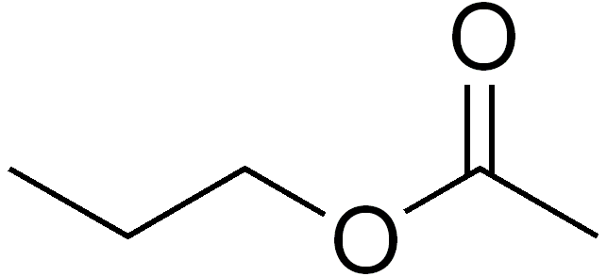 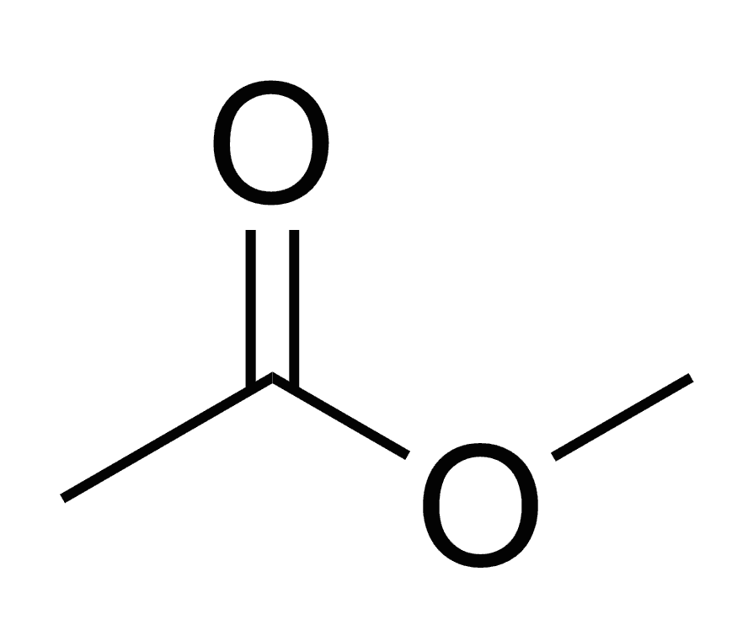 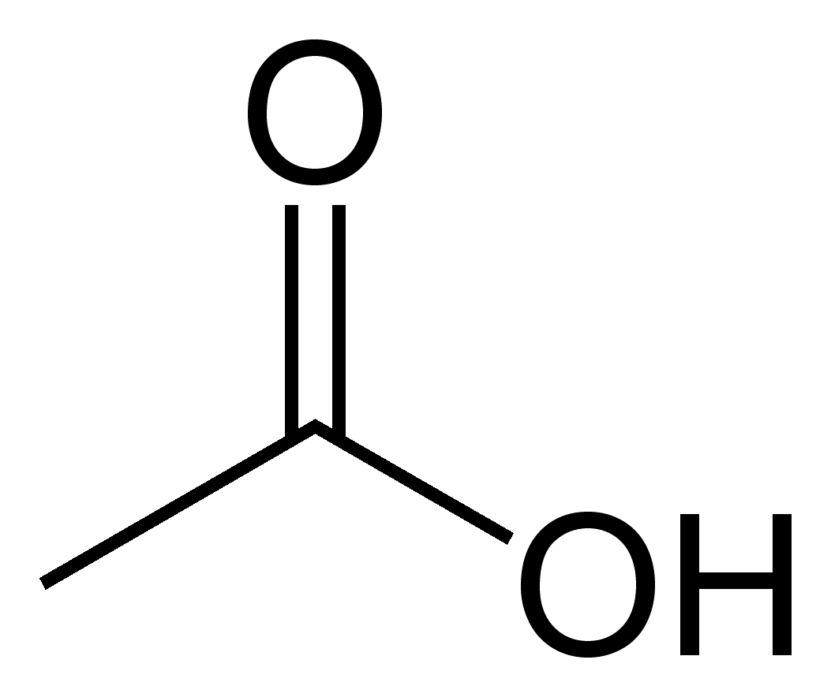

Acetic acid

Methyl acetate

Propyl acetate

Distillation is vaporizing a liquid, then condensing it into vapor, and collecting the condensate. The main purpose of distillation is to purify liquid compounds and/or solvents to be removed from non-volatile materials. In general there are four different distillation techniques: simple. Fractional, steam, and vacuum; in this particular experiment, as stated above, only two would be used: simple and fractional distillation. Although, ideal separations aren’t achieved when the two compound’s boiling points are less than 10oC difference. In this experiment, students will be working in pairs, and each one would be assigned fractional distillation or simple distillation. After the distillation process, students would be performing a Gas Chromatography (GC or GLC). In GLC, the stationary phase is a high-boiling liquid and the mobile phase is an inert gas. It is similar to the TLC process as it can also be used to separate small quantities of compounds. Although, a compound with lower boiling point will spend a lot more time in the gas phase than the liquid phase, which is contrary to compound with a higher boiling point. This would allow the carrier gas to have it swept even faster. In addition, there are certain conditions that can be foreseen from the start, such as, polar compounds would move slowly (especially if the column is polar), raising the temp. of the column speeds up the compound in the mixture; speeding up the carrier gas flow will increase the speed of the compounds moving through the column; longer the column, the longer it will take the compounds to elute (although it makes a better separation). However, all these factors would remain constant during lab.  
The main theory behind the GLC is that a small amount of mixture is inserted in the instrument and then it is volatized in a hot injection chamber. Then, swept by a steam of inert carrier gas, usually helium or nitrogen (helium is a better option as it has better thermal conductivity) through the heated column containing the stationary phase (a high boiling liquid). When this happens, the mixture’s components travel back and forth at various different rates between dissolution in the high-boiling liquid and the gas phase. This allows the GLC technique to separate mixtures into pure components. Before the compound exits the instrument, the detector, thermal conductivity and flame ionization detectors, (last phase of the process), notices the compound and then sends an electronic message to the recorder, which then shows a peak on a piece of paper. This is because, assuming that we use the thermal conductivity detectors, the detector has a “Wheatstone Bridge circuit” that is sensitive to differences in thermal conductivity which could be caused by the presences of different compounds in the carrier gas, which it then compares it to the thermal conductivity of a carrier gas as a reference. Then it notices a difference, at that particular point, it changes its voltage and sends an electronic message to the recorder. There could be two types of recorders, an integrating recorder, and a program on the computer. The message delivered would consist peaks and retention time (time it takes for a compound to move from the injection port to the detector), as well as an area under the curve. Basically, it will give a ratio that can be seen as a percentage of the two components.  
  
**Safety Precautions**

*Both, methyl acetate and propyl acetate are flammable. Do not distill to dryness, since it can lead to a potentially hazardous situation.*

**Wastes**

* Recovered distillate bottle: pot residue, all distillation fractions, and GC samples.
* Boiling chips can be placed in the white solid waste bins in the front of the lab.

**Physical Data**

|  |  |  |  |  |
| --- | --- | --- | --- | --- |
| Name | Composition | Polarity | | Applications |
| Squalene and apiezon | Hydrocarbon | Nonpolar | | Saturated hydrocarbons |
| OV-1, OV-101 | Dimethylsilicone | Nonpolar | | Mines, alcohols, ketones, alkaloids, hydrocarbons |
| SE-30 | Methylsilicone | Low polarity | | Amines, alcohols, ketones, alkaloids, hydrocarbons |
| Carbowax | Polyethylene glycol | Medium high polarity | | Polar compounds: alcohols, ethers, amines, aldehydes, ketones |
| DEGS | Diethylene glycol succinate | High polarity | | Polar compounds: esters, acids |
| Name | | | Boiling point | |
| Methyl acetate | | | 56.9oC | |
| Propyl acetate | | | 102oC | |

**Procedure**  
  
*Simple Distillation:*

1. Gather all the glassware
   1. Y-adaptor, round-bottom flask (distilling flask), thermometer adaptor, condenser, vacuum adaptor (bent adaptor), graduated cylinder(receiving flask).
2. Place a ring stand and clamp the distillation flask to it.
   1. Do not let the distillation flask to fall as it contains your compound.
   2. Only have it filled ½ to 2/3 of the flask’s volume.
3. Connect the Y-adaptor on top of the distilling flask and the condenser on the right of it.
4. Clamp the condenser to another ring stand.
5. Use yellow clips to secure the condenser between the y-adaptor and the vacuum adaptor.
6. Connect the lower water-jacket outlet of the condenser to the water and the other to the drain.
7. Place an 10ml graduate cylinder (receiving flask under the vacuum adaptor.
8. Place the heat source under the round-bottom flask (distilling flask)
   1. Plug the heat source (heating mantle) into a Variac; and never plug the heating mantle directly to an electrical outlet. Do not turn it on yet.
9. You are going to distill 25ml of 1:1 (by volume) methyl acetate: propyl acetate mixture.
10. Fill in the 25ml mixture using a funnel, through the y-adaptor, before adding the thermometer in (it is always placed at the end to prevent breakage).
11. Position the thermometer from the top of y-adaptor so that the bulb is below the bend of the y-adaptor.
12. To cool the condenser, turn on the water (make sure your water hoses are securely tight)
13. Set the Variac to amount 50 and after! Turn it on.
14. When the mixture begins to boil adjust it so that there is only 1-2 drops/sec.
15. Drops will start appearing in the 10ml graduated cylinder (receiving flask).
    1. You should be recording the temperature at each 1.0ml increase in the graduated cylinder.
    2. After 3ml have been collected in the receiving flask, substitute the graduated cylinder with a simple vial.
    3. Collect around 20 drops in the sample vial, cap it and save this sample for GC analysis.
       1. IF you don’t cap it, the sample would evaporate.
    4. Then place the graduated cylinder back as a receiving flask and continue collecting drops a recording data at every 1.0ml increase.
16. If the distillation slows down during this process, increase the amount on Variac to 60.
17. When 15ml has been collected, remove the graduated cylinder and substitute it with another sample vial and collect 20 drops.
    1. Close the cap!
18. Stop distillation after 20 ml has been collected or before the distillation pot is dry.

*Fractional Distillation:*

1. Same procedure as the simple distillation but with a fractionating column between the distilling pot and the y-adaptor.
   1. If you heat up or cool down too fast, the fractionating column is subject to flood. Also when they are too tightly packed. If it floods, remove the heat source immediately, until the liquid pool has returned to the pot. Then begin again with a lower heat input.
   2. If it still floods, change the column.

*Gas Chromatography:*

1. Take a 25µl glass Hamilton syringe.
2. Take the syringe and place the tip of the needle in the sample liquid in the sample vial.
   1. Draw a small amount of liquid by raising the plunger, and then plunger it back to expel the liquid back into the sample vial. This serves as a rinsing process, do it 2-3 times.
3. After rinsing, draw the liquid about half-way up “5”.
   1. If you have too much then the peak would be off the scale in the readings.
   2. Hold it up in the light to see whether the sample is included or not. It is generally hard to see, but if you see tiny air bubbles then its okay. But if you see a large air bubble, do this step again.
4. There are couple of settings that need to be controlled for each run such as the following:

|  |  |
| --- | --- |
| Start temperature | 65oC |
| Hold time | 1 min |
| Ramp rate | 10oC/min |
| Final temperature | 65oC |
| Hold time | 2 min |
| Total length | 6.0 min |
| Pressure | 7.0kPa |

1. Inject the sample into the injector port, this needs to be done sequentially and quickly
   1. You need to be sure of where the injection port is and the start button (there is a diagram in the *Handbook for Organic Chemistry* on p. 142)
   2. Push the needle into the injection port, all the way to the base of the needle and then quickly plunger to inject the sample. ***Immediately*** press the “start” button on the recorder/computer.
   3. Record all the conditions used for each GC run.
2. When all the peaks are shown that you assume are in the mixture, or when there is a flat baseline on the recorder, press “Stop” on the recorder/computer.
3. A print will come out of the recorder to indicate the RT, peaks, and the areas under the peaks.
4. If you have a good idea of the identity of the sample that you are injecting into the GC, then it is a good idea to authenticate the assumption by running an authentic sample of that compound as a standard.
   1. To run an internal standard, run the mixture that you are supposed to be analyzing and then save the GC trace.
   2. Add the known standard to the mixture and run the GC.
   3. Compare the GC traces from before and after the addition of the standard
   4. If there is an increase in size of one of the GC peaks, indicates that the compound in this peak is the same as the standard. In other words, verifying the identity of your compound.